M 091
MODEL PAPER
B.E. DEGREE EXAMINATION.
Fourth Semester
Production Engineering
PR 238 — FLUID POWER DRIVES AND CONTROLS
Time : Three hours Maximum : 100 marks
Answer ALL questions.
PART A — (10 × 2 = 20 marks)
- Compare the hydraulic and pneumatic systems.
- Draw the symbols of the following :
(a) 5/2 direction control valve–pilot operated and spring return
(b) Pressure relief valve.
- Distinguish between the positive and non–positive displacement pumps.
- Why the volumetric efficiency of a positive displacement must be rated with pressure?
- What is an FRL unit and mention its use?
- Name any four ways of mounting the cylinders.
- What is a Latch circuit?
- What is a Coanda Effect?
- Distinguish between PLC and computer.
- What is a travel step diagram?
PART B — (5 × 16 = 80 marks)
- (i) Discuss the merits of Fluid power system and compare it with other drive system. (4)
(ii) Metal sheets are to be flanged on a pneumatically operated bending tool. After clamping the component by means of a single acting cylinder A, it is bent over by a double acting cylinder B and subsequently finish bent by another Double acting cylinder C. The operation is initiated by a manual push button.
Auxillary conditions :
(1) Only one working cycle is to be completed each time a start signal is
given.
(2) Cylinder B for bending operation may only advance when clamping
cylinder A has reached its from end position and the required
clamping pressure is available, design a suitable circuit.
Positional sketch :
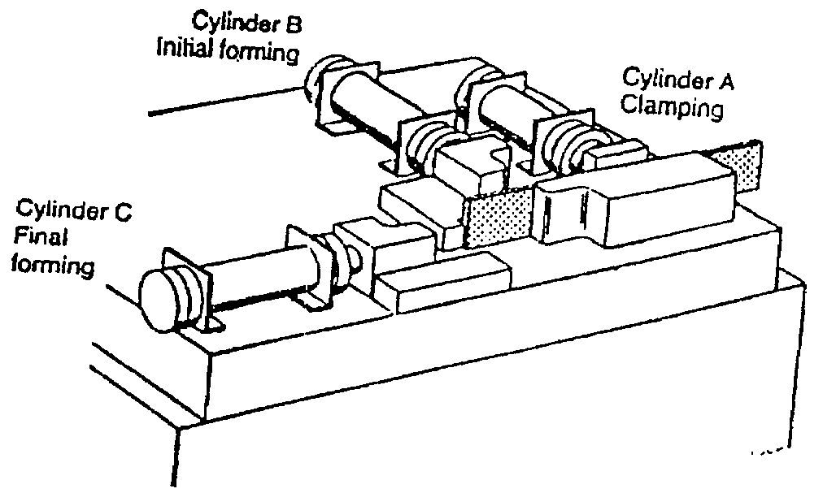
- (a) (i) How pumping action is accomplished in a positive displacement
pump? (6)
(ii) Describe the principle, operation and construction of a Vane pump.
(10)
Or
(b) (i) What is a hydrostatic drive and explain its advantages? (4)
(ii) Explain with neat sketch the principle of operation of a axial piston
pump and also derive an expression when the pump is converted as
a motor. (12)
- (a) (i) What is a counter balance valve? Explain its significance. (6)
(ii) Explain with neat sketch the construction and operation of a
Balanced piston pressure relief valve. (10)
Or
(b) (i) List down the different types of pressure control valves. (4)
(ii) What is a accumulator and explain the working details of any two
types? Sketch any two–accumulator circuits.
- (a) Design a sequencing circuit for the sequence shown below by Cascade method $A+ A− B+ B− C+ C−$ where + stands for forward stroke
and – stands for return stroke of the cylinder.
Or
(b) (i) What is the Hi–Lo circuit? Explain its use. (8)
(ii) Distinguish meter in, meter out and bleed off circuits. Explain their
selection criteria. (8)
- (a) Design and draw a electro pneumatic sequencing circuit for the sequence $A+ B+ B− A−$ by Karnaugh vetich map method.
Or
(b) (i) Draw a electro pneumatic ladder diagram for $A + A− B+ B−$. (10)
(ii) Modify the above electro pneumatic ladder diagram for a PLC. (6)
—————

